**PLEASANT TOURS**

**Developer Guide**

|  |  |  |
| --- | --- | --- |
| **Faculty** | **Miss Neelam Malik** | |
| **Batch** | **2209B1** | |
| **Group** | **C** | |
| **Serial No.** | **Enrollment Number** | **Student Name** |
| 1. | Student1412237 | MUHAMMAD AQDAS |
| 2. | Student1412235 | ABUBAKAR ALI |
| 3. | Student1407855 | UBAID UR REHMAN |
| 4. | Student1412215 | MUHAMMAD WASAY |

**Screenshots**

**Home page**

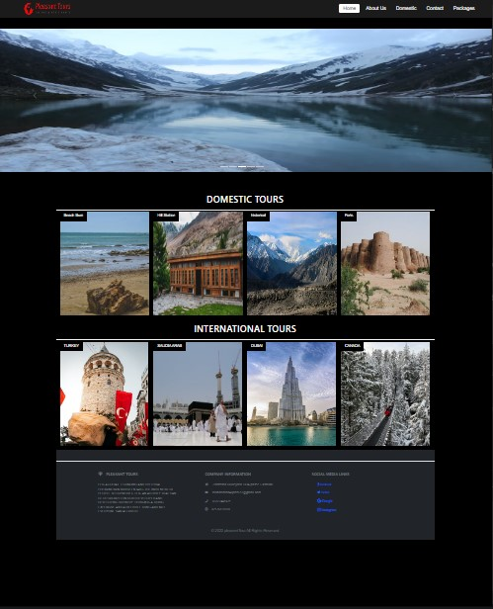

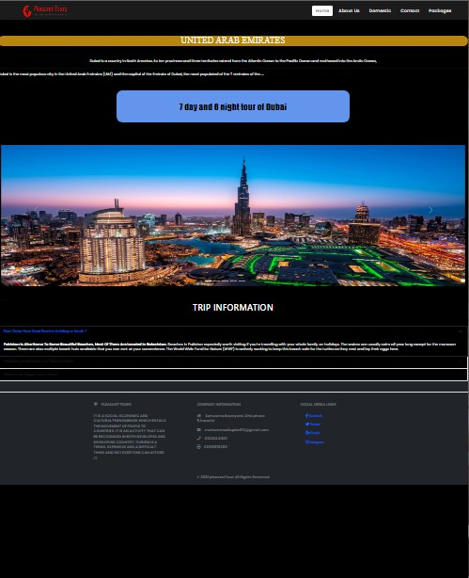

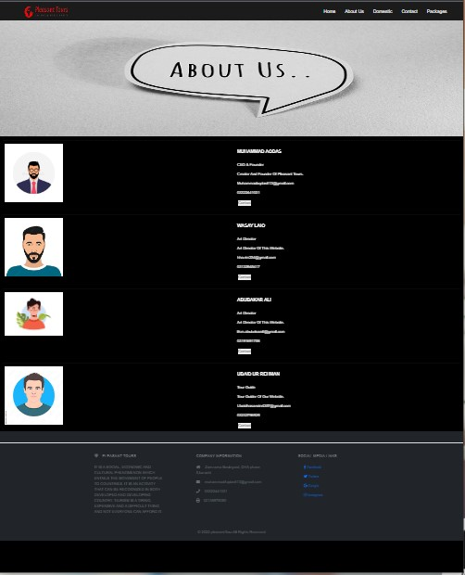

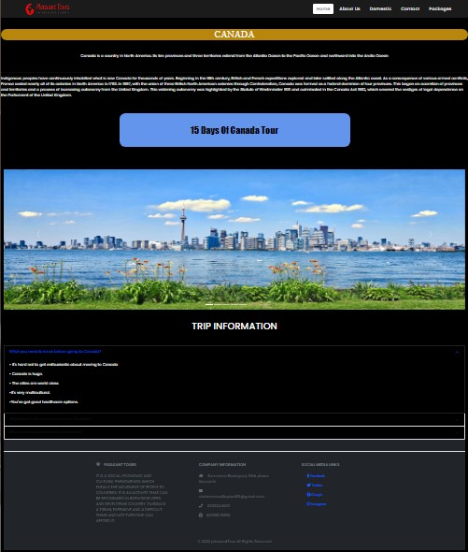

**TASK SHEET REVIEW 2**

|  |  |  |  |  |  |  |
| --- | --- | --- | --- | --- | --- | --- |
| Project Ref. No.: eP/Advertisement Portal Management System/01 | | Project  title | Date of Preparation of Activity Plan | | | |
| No | Task | Garden World | Actual | Actual | Team-mate | Status |
| Start Date | Days | Names |
| 1 | Navbar | 09/JAN/2023 | 1 | MUHAMMAD AQDAS | Complete |
| 2 | Main Body Navbar | 09/JAN/2023 | 1 | MUHAMMAD AQDAS | Complete |
| 3 | Footer | 09/JAN/2023 | 2 | MUHAMMAD AQDAS | Complete |
| 5 | Canada | 09/JAN/2023 | 4 | MUHAMMAD AQDAS | Complete |
| 6 | About Us | 09/JAN/2023 | 3 | MUHAMMAD AQDAS | Complete |

**TASK SHEET REVIEW 3**

|  |  |  |  |  |  |  |
| --- | --- | --- | --- | --- | --- | --- |
| Project Ref. No.: eP/Advertisement Portal Management System/01 | | Project title | Date of Preparation of Activity Plan | | | |
| No | Task | Pleasant Tours | Actual  Start Date | Actual  Days | Team-mate  Names | Status |
| 1 | Dubai | 09/JAN/2023 | 2 | MUHAMMAD AQDAS | Complete |
| 2 | Muree | 09/JAN/2023 | 3 | UBAID UR REHMAN | Complete |
| 3 | Domestic | 09/JAN/2023 | 2 | UBAID UR REHMAN | Complete |